The Right Home for Your Rabbit

Congratulations on the adoption of your pet rabbit! You are sure to have many wonderful days ahead with this new member of your family. Be sure to talk to your veterinarian about the right diet and care your bunny needs to live a long and healthy life.

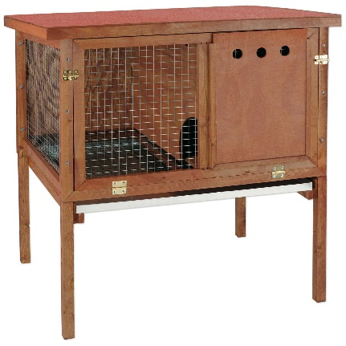
An important component of good “bunny care” is proper housing. In Hawaii, there are special requirements for keeping rabbits. Rabbits are notorious escape artists, great diggers, and like to make families! The #1 cause of loose and lost rabbits is unprepared pet owners who don’t provide the right kind of home for their rabbits.

What is the right home?
The right home for your bunny is up off the ground, and with males and females kept separately. A secure, standing hutch will give your bunny protection from predators, a dry floor to walk on, and ensure you won’t end up with a disappearing act!

Why is it important?
Rabbits aren’t native to Hawaii, and our already threatened ecosystems are not able to defend against an influx of new herbivores. Introduced rabbits in other places, like Australia, cost millions to farmers each year. Our food security depends on responsible pet owners like you making sure rabbits don’t become a problem in Hawaii.

There’s a reason we use the expression “breed like rabbits”: bunnies can have litter of up to 8 babies 6 times a year – that’s nearly 50 baby bunnies per year!

Of course, you want to protect your rabbit and keep him or her safe. Loose rabbits are at risk for encounters with mongoose, cats, and dogs, not to mention motor vehicles.

Also…it’s the law! According to Hawaii State Law (HRS 142-95) Failure to keep rabbits in a secure hutch off the ground can lead to a fine of up too $100. It is also a violation to release a rabbit into the wild. The Hawaii Island Humane Society is always available to accept animals from the public at absolutely no cost, and will happily re-home your rabbit if it doesn’t work out.

