Herbicide Labels:
Milestone® Specialty Herbicide, EPA Reg No. 62719-519 (Dow AgroSciences LLC, Indianapolis, IN). http://www.cdms.net/LDat/ld77N015.pdf

Guides for Herbicide Injection:
Practitioner’s Guide for Testing Herbicide Efficacy with the Incision Point Application (IPA) Technique on Invasive Woody Plant Species. http://www.ctahr.hawaii.edu/oc/freepubs/pdf/WC-11.pdf

Practitioner’s Guide for Effective Non-Restricted Herbicide Techniques to Control and Suppress Invasive Woody Species in Hawaii. http://www.ctahr.hawaii.edu/oc/freepubs/pdf/WC-10.pdf

Guides for Measuring Tree Height:
http://www.ctahr.hawaii.edu/forestry/links.html
http://www.wikihow.com/Measure-the-Height-of-a-Tree
https://play.google.com/store/apps/details?id=com.taakkumn.iHypsometerLite&hl=en

Local Sources for Herbicide Purchasing:
Garden Exchange
http://www.gardenexchangehilo.com

BEI Hawaii
http://www.beihawaii.com

Crop Production Services Inc.
http://www.cpsagu.com/regions/Hawaii

Key search terms for online purchasing:
Drop Dispenser Bottle, Hatchet, Bush Pilot Hatchet, Survival Hatchet, Camping Hatchet

Contributors:
James Leary¹, JB Friday¹, Springer Kaye², Flint Hughes³
¹ Department of Natural Resources and Environmental Management (NREM), College of Tropical Agriculture and Human Resources (CTAHR), University of Hawai‘i at Manoa (UHM)
² Big Island Invasive Species Committee (BIISC), Pacific Cooperative Studies Unit (PCSU), University of Hawai‘i at Manoa
³ Institute of Pacific Island Forestry (IPIF), USDA Forest Service

Acknowledgements:
Nick Dudley, Hawaii Agriculture Research Center (HARC), Linda Cox (NREM), Piihonua Albizia Control Team (PACT).

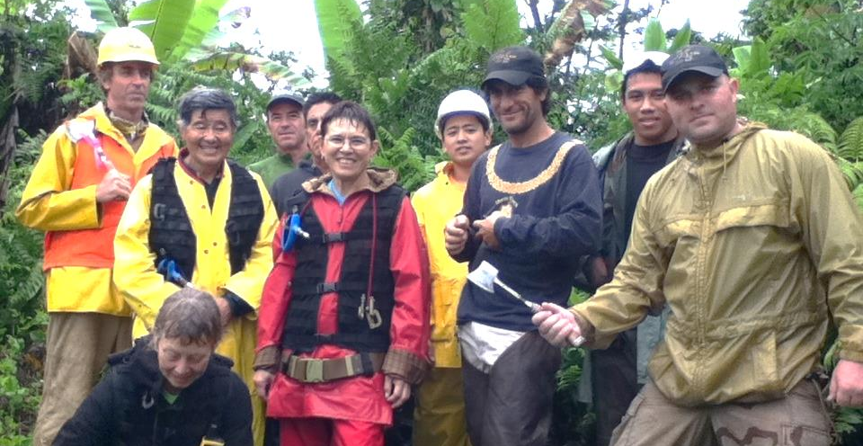

Disclaimer:
Mention of specific brand names does not constitute endorsement on the part of the authors, CTAHR, or the University of Hawai‘i.

Published by the College of Tropical Agriculture and Human Resources (CTAHR) and issued in furtherance of Cooperative Extension work, Acts of May 8 and June 30, 1914, in cooperation with the U.S. Department of Agriculture, under the Director/Dean, Cooperative Extension Service/CTAHR, University of Hawai‘i at Mānoa, Honolulu, Hawai‘i 96822.Copyright 2011, University of Hawai‘i. For reproduction and use permission, contact the CTAHR Office of Communication Services, ocs@ctahr.hawaii.edu, 808-956-7036. The university is an equal opportunity/affirmative action institution providing programs and services to the people of Hawai‘i without regard to race, sex, gender identity and expression, age, religion, color, national origin, ancestry, disability, marital status, arrest and court record, sexual orientation, or status as a covered veteran. Find CTAHR publications at www.ctahr.hawaii.edu/freepubs.

Proper Technique for Injecting Albizia (Falcataria moluccana L.) with the herbicide Milestone® (active ingredient: Aminopyralid)

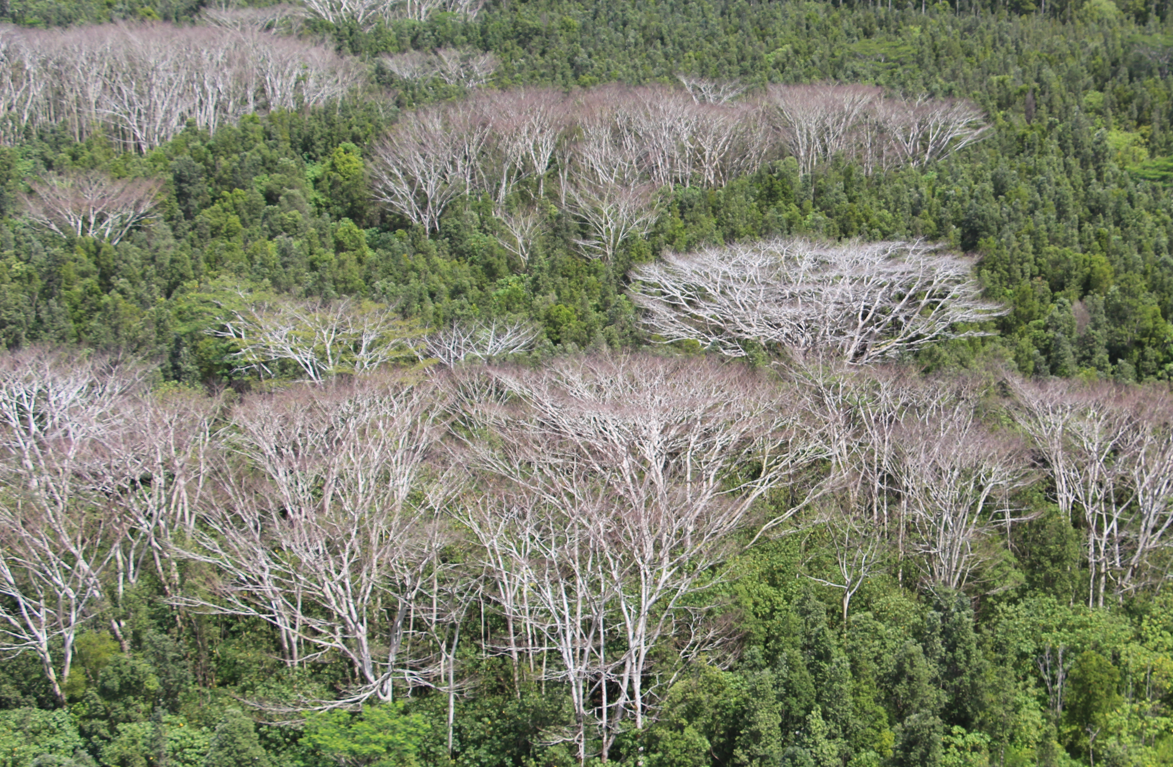

This guide explains how to administer an effective herbicide injection application to medium and large albizia canopy trees occupying natural areas in accordance to the Milestone® Specialty Herbicide, (EPA Reg No. 62719-519). This guide was updated 9/1/2016. It is a violation of Federal law to use this herbicide in a manner inconsistent with its registered application methods. ALWAYS READ THE LABEL FIRST!

The injection method, also known as Incision Point Application (IPA), is a calibrated, hygienic, and efficient technique for administering suppressive or lethal herbicide doses directly to the exposed vascular systems of woody species. In previous studies, Milestone® (active ingredient aminopyralid; Dow AgroSciences LLC, Indianapolis, IN) injections were proven to be lethal to 12 in. trunk diameter, albizia trees administered with a 0.5 ml dose of undiluted herbicide injected into hatchet incisions spaced every 10 in. around the circumference of the trunk, at a height within 3 ft. above ground level. For trunks >24 in. diameter, injections should be spaced every 5 in. For trunks >36 in. diameter injections should be spaced every 2 in. (complete girdle).

Application Technique:
1. Make an incision with the hatchet at a 45º angle that penetrates just beyond the bark and cambium layers (approximately 2-3 in. deep) so that it creates an intact trough/notch (see figure). You may widen the notch by wiggling the blade.
2. With a dropper bottle, deliver the herbicide dose to the center of the incision so that all of the herbicide is retained within the trough. This is accomplished by slowly and precisely squeezing the bottle to deliver one drop at a time. Be sure that the incision is deep enough to prevent the herbicide from overflowing at the seam. Dropper calibrations have consistently measured 11-12 drops per 0.5 ml, but may vary and should be tested.

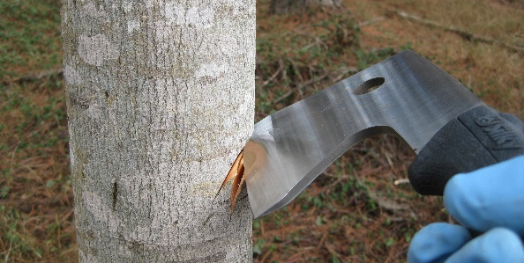
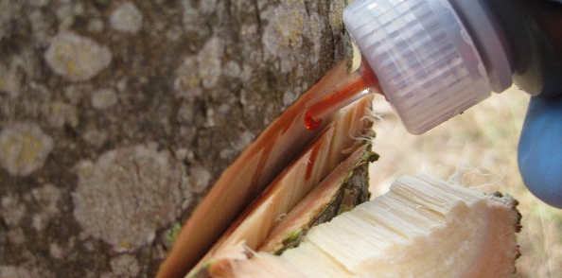
Steps to a proper injection: (i) incision using a hatchet on an angle to create a clean, intact trough; (ii) herbicide drops retained and absorbed into the vascular system of the target tree; (iii) large size tree with close injection spacing.

Equipment and Resources:
- Hatchet/machete
- Drop Dispenser Bottles (1-8 fl. oz.)
- Herbicide formulation
- Tape measure
- GPS
- PPE: safety goggles and nitrile gloves

Management Plan:
1. This method is only for use on trees that can be treated without risk to buildings and infrastructure.
2. Do not exceed the maximum allowable amount of 7 fl. oz. per acre, which is equal to 414 injections (0.5 ml each). Medium size trees are treated with 2-3 ml total, which is enough for up to 200 trees per acre (~50 large trees).
3. Do not treat large trees that may damage infrastructure and block right-of-ways. Estimate impact zone to be greater than the height of the tree (see guides for measuring tree height).
4. Dead standing trees are brittle and dangerous to cut: if you plan to cut the trees down, do not use this technique.
5. Consult with a certified arborist for proper removal of large trees.

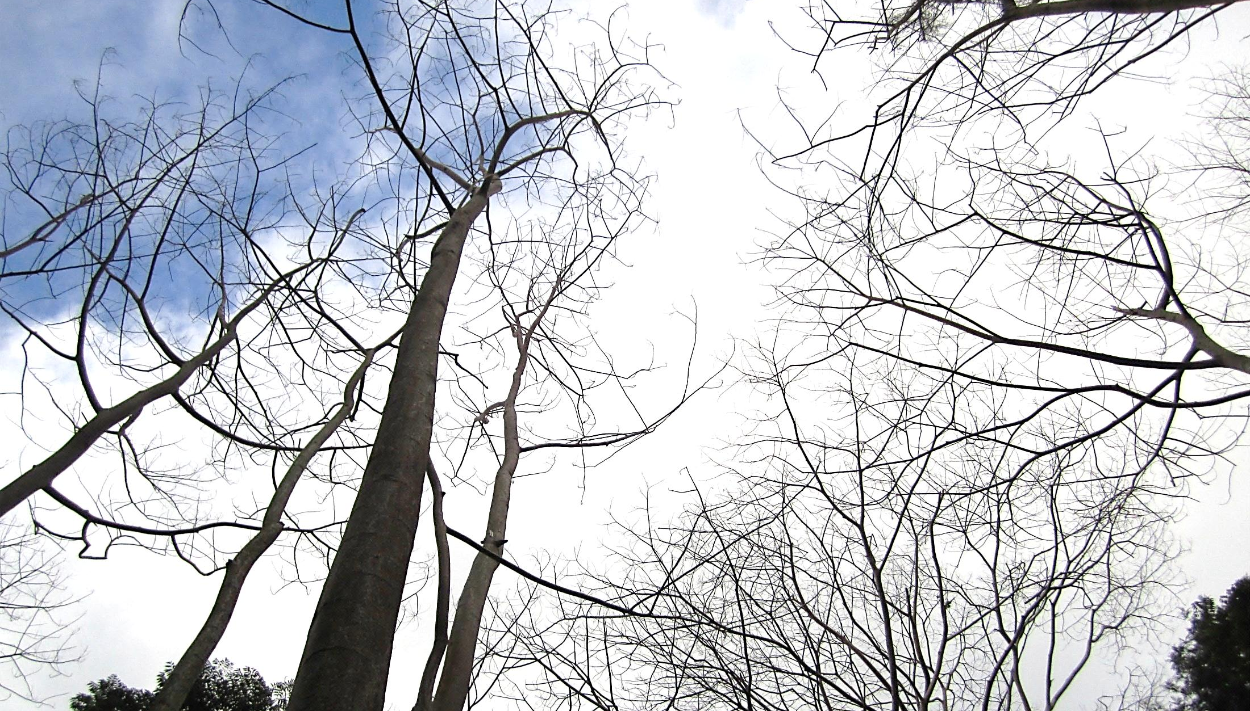
CAUTION! Dead standing trees are hazardous to property and personal safety!

Expected Results:
Warning! This technique leaves dead trees in place. Complete canopy defoliation can be expected within 4-6 weeks. Canopy collapse can be expected within 2 years and may continue decomposing for a decade or longer. Retreatment of large trees may be necessary if new leaf canopy is observed 12 months after first treatment.

